VGG16 Model Architecture

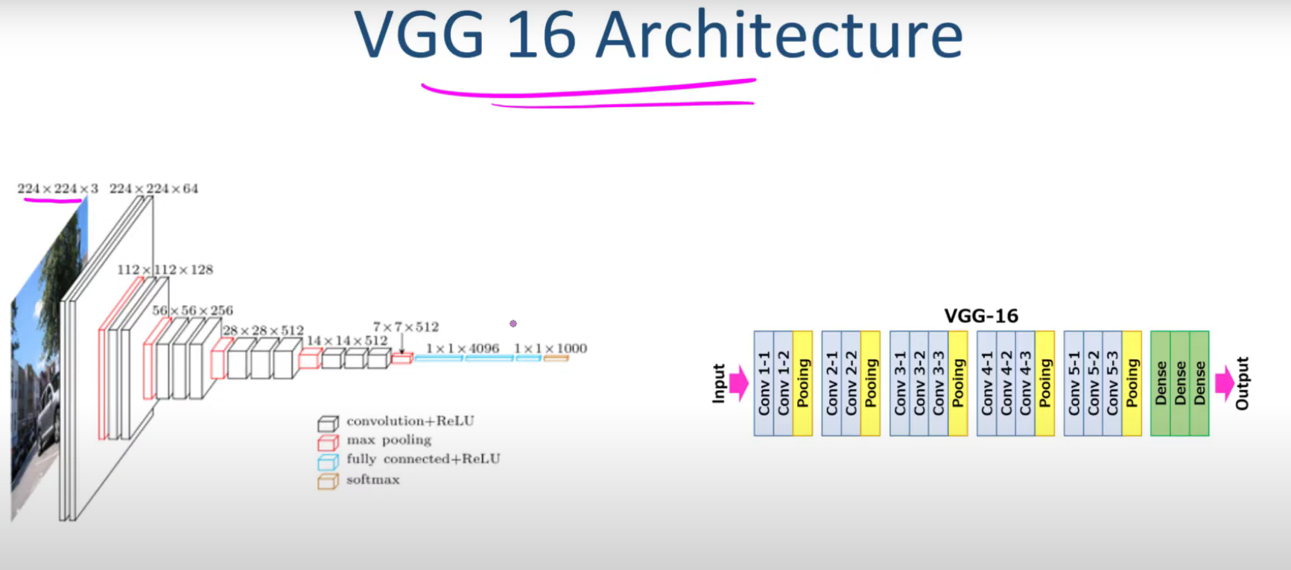

Layers:  
  
2-1-2-1-3-1-3-1-3-1-FC-FC-FC --- ImageNet-1000

AlexNet VS VGG16:

**Overview of VGG16 Architecture**

* Explanation of VGG16 layers: convolutional, max pooling, and fully connected layers.
* Input image size: 224×224×3 (RGB).
* The final fully connected layer outputs 1,000 categories based on the ImageNet dataset.

**Layer Structure of VGG16**

* Layer sequence:
  + Two convolutional layers → Max pooling
  + Two convolutional layers → Max pooling
  + Three convolutional layers → Max pooling
  + Three convolutional layers → Max pooling
  + Three convolutional layers → Max pooling
* Fully connected layers at the end.

**Comparison with AlexNet**

* AlexNet has varying filter sizes (e.g., 11×11, 5×5), making it complex to remember.
* VGG16 standardizes filter size (3×3), stride (1), and padding (same), simplifying calculations.

**Filter Sizes and Stride in VGG16**

* Convolutional layers use 3×3 filters, stride 1, and same padding.
* Max pooling layers use 2×2 filters with stride 2, reducing image size by half.
* Explanation of how feature maps change through layers.

**Mathematical Calculation for Output Size**

* Formula for output size calculation: output=input size+2p−fs+1\text{output} = \frac{\text{input size} + 2p - f}{s} + 1output=sinput size+2p−f​+1
* Example: A 224×224 image reduces to 112×112 after max pooling, then to 56×56, 28×28, 14×14, and 7×7.

**Increasing Number of Filters**

* Filters increase progressively: 64 → 128 → 256 → 512.
* Fully connected layers process the final 7×7×512 feature map.

**Key Advantages of VGG16 Over AlexNet**

* Consistent 3×3 convolutional filters ensure simplicity and efficiency.
* Max pooling with 2×2 filters reduces complexity and improves feature extraction.
* Deeper architecture (16 layers) leads to better learning capabilities.

**Limitations:**

**High computational cost**: Requires more **memory (138M parameters)** and **processing power**.

**Slower training**: Compared to ResNet and EfficientNet.

**Not the best accuracy**: More advanced models (ResNet, DenseNet) outperform VGG16.

**Summary of VGG16 Advantages**

1. **Deep but Simple Architecture** – Uses 16 layers with small **3×3 filters**, enhancing feature learning.
2. **Better Feature Extraction** – Captures **hierarchical patterns** and is effective for **transfer learning**.
3. **Consistent Structure** – Follows a **sequential** design, making it easy to understand and implement.
4. **Good Classification Performance** – Achieved a **7.3% top-5 error rate** in ImageNet and is widely used in vision tasks.
5. **Pretrained Models for Transfer Learning** – Available in frameworks like **TensorFlow & PyTorch**, reducing training time.
6. **Better Generalization** – Small filters and deep layers help adapt to unseen images.
7. **Effective Max-Pooling** – Uses **2×2 pooling** to retain essential features while reducing spatial dimensions.

Difference between the Resnet and VGG16:

|  |  |  |  |  |  |  |
| --- | --- | --- | --- | --- | --- | --- |
| Feature | VGG16 | ResNet (e.g., ResNet-50) |  |  |  |  |
| Architecture | Sequential, deep with 16 layers | Residual connections with deeper networks (50, 101, 152 layers) | | | |  |
| Filters | Uses small 3×3 filters throughout | Uses 3×3 and 1×1 filters, optimized with residual blocks | | |  |  |
| Performance | Good for feature extraction but suffers from vanishing gradients in deeper networks | Better accuracy due to skip connections (solves vanishing gradient problem) | | | | |
| Computational Cost | High (138M parameters) | More efficient due to residual connections (ResNet-50: ~25M parameters) | | | | |
| Training Speed | Slower due to deep architecture and lack of shortcuts | Faster convergence due to residual learning | |  |  |  |
| Transfer Learning | Widely used for transfer learning | Preferred for transfer learning due to better feature reuse | | | |  |
| Generalization | Generalizes well but struggles with very deep architectures | Excellent generalization due to residual learning | | |  |  |
| Best Use Case | Simple classification, feature extraction | Deep learning applications requiring high accuracy | | |  |  |